SAFETY DATA SHEET
OSHA HCS (29 CFR 1910.1200)

SECTION 1: PRODUCT AND COMPANY IDENTIFICATION
Product identifier
 | Chemical Family / Chemical Name | Mixture
 | CAS No. | Mixture
 | Trade Name | MC-1840
 | Product Code | None
Relevant identified uses of the substance or mixture and uses advised against
 | Identified Use(s) | Precipitant
 | Uses Advised Against | None
 | Company Identification | Meitler Consulting, Inc  16979 Chieftain Rd  PO Box 444  Tonganoxie, KS 66086 USA
 | Telephone | (913) 422-9339
 | Fax | (913) 422-9344
 | E-mail
Emergency telephone number
 | Emergency Phone No. | Transportation Emergency: CHEMTREC 24 hr. 1-800-424-9300 / 1 (703) 527-3887 (Collect calls accepted)

SECTION 2: HAZARDS IDENTIFICATION
Classification of the substance or mixture
 | OSHA HCS (29 CFR 1910.1200) | Skin Irrit. 1B; Eye Dam. 1; Acute Toxicity (Oral = 3/ Inhalation = 4)
Label elements
 | Hazard Symbol | 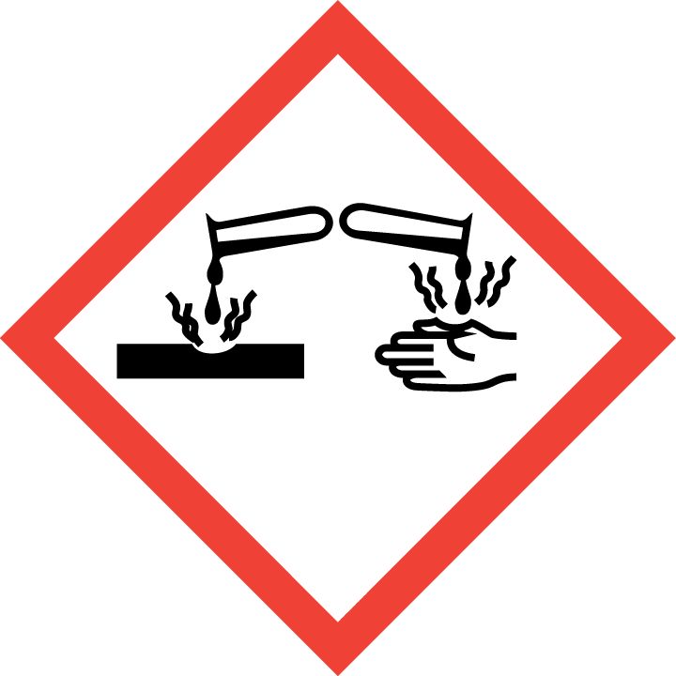
 | Signal Word(s) | DANGER
 | Hazard Statement(s) | Causes serious eye damage .Causes severe skin burns and eye damage . May be corrosive to metals . Very toxic to aquatic life  Toxic if swallowed. Harmful if inhaled
 | Precautionary Statement(s) | Wear protective gloves/protective clothing/eye protection/face protection.  Wash thoroughly after handling.  IF ON SKIN: Wash with plenty of soap and water. If irritation (redness, rash, blistering) develops, get medical attention.  IF IN EYES: Rinse cautiously with water for several minutes. Remove contact lenses, if present and easy to do. Continue rinsing. Get immediate medical attention.  IF SWALLOWED: rinse mouth. Do NOT induce vomiting. Seek medical treatment.
Other hazards |  | None
Additional Information |  | Warning - this preparation contains a substance not yet tested completely.

SECTION 3: COMPOSITION/INFORMATION ON INGREDIENTS

Hazardous Ingredient(s) | % wt. | CAS No.
Sodium Hydrosulfide Solution  Water | Trade Secret  Trade Secret | 16721-80-5  7732-18-5
Additional Information - Substances in the product which may present a health or environmental hazard, or which have been assigned occupational exposure limits, are detailed below.:

SECTION 4: FIRST AID MEASURES


Description of first aid measures
 | Inhalation |  | Call a Poison Center or doctor/physician if exposed or you feel unwell. Remove person from source of exposure to fresh air. If breathing is difficult, give oxygen. If not breathing, give artificial respiration using a pocket mask or resuscitation device. Direct mouth contact should be avoided if possible due to the potential for residual corrosive liquid around the person's mouth and airways.
 | Skin Contact |  | Immediately remove contaminated clothing and shoes. In case of contact, immediately flush skin with soap and plenty of water. Get medical attention immediately if irritation (redness, rash, blistering) develops and persists.
 | Eye Contact |  | In case of contact, immediately flush eyes with plenty of water for at least 20 minutes. Get medical attention immediately. Person may be kept in a dark room with ice compresses applied to eyes and forehead until medical treatment is available. Speed in treatment may prevent permanent eye damage.
 | Ingestion |  | Call a physician or a poison control center immediately. If vomiting occurs, keep head low so that stomach contents do not enter the lungs.  If conscious, rinse the mouth out several times with cold water and spit out. Give one or two cups of water or milk. This may be followed by gastric antacids, such as milk of magnesia or aluminum hydroxide. Stop if victim becomes nauseated. DO NOT INDUCE VOMITING unless instructed to do so by medical personnel. Never give anything by mouth to an unconscious person. If the victim stops breathing: administer artificial respiration with the aid of a pocket mask equipped with a one-way valve or other proper respiratory medical device.
Most important symptoms and effects, both acute and delayed |  |  | Some medical protocols prescribe the use of amyl nitrite as part of first aid treatment. Do not use amyl nitrite treatment if oxygen is not available. Amyl nitrite is only a useful adjunct during the first 10 to 15 minutes following exposure. Once breathing is restored, provide a high flow of oxygen and amyl nitrite if appropriate Symptoms of pulmonary edema may be delayed for 24 to 72 hours after initial exposure. Therefore, hospitalization and medical observation is advisable during this period.
Indication of any immediate medical attention and special treatment needed |  |  | Treat symptomatically

SECTION 5: FIRE-FIGHTING MEASURES
Extinguishing Media
-Suitable Extinguishing Media |  | Non-combustible / Non-flammable. As appropriate for surrounding fire. Lower Explosive Limit: 4% (hydrogen sulfide) Upper Explosive Limit: 46% (hydrogen sulfide)
-Unsuitable Extinguishing Media |  | As appropriate for surrounding fire.
Special hazards arising from the substance or mixture |  | Product solution is non-flammable. However, trace levels of flammable hydrogen sulfide gas are continuously released in air, especially when product is heated or exposed to acids. Gas may form explosive mixtures in air. Do not cut open or apply heat sources to containers. Thermal decomposition ("burning") may evolve toxic and irritating combustion by-products - hydrogen sulfide.
Advice for fire-fighters |  | Avoid breathing vapors, gases and fumes. Do not touch, handle or walk-through spilled liquid. Firefighters should wear a positive pressure-demand self-contained breathing apparatus (SCBA) and full protective gear. Containers may build up pressure if exposed to radiant heat. Water can be used to cool and protect exposed material. Do not allow runoff to enter sewers or waterways. Move containers away from fire area if safe to do so.

SECTION 6: ACCIDENTAL RELEASE MEASURES
Personal precautions, protective equipment and emergency procedures | Put on protective equipment before entering danger area. Wear protective gloves/protective clothing/eye protection/face protection.
Environmental precautions | Prevent substance entering sewers.
Methods and material for containment and cleaning up | Cover spills with inert absorbent material. Transfer to a container for disposal or recovery.
Reference to other sections | None
Additional Information | None

SECTION 7: HANDLING AND STORAGE
Precautions for safe handling | Wear protective gloves/protective clothing/eye protection/face protection. Avoid breathing vapour, gas or mist. Use only with adequate ventilation.
Conditions for safe storage, including any incompatibilities
-Storage temperature | Keep away from heat or flame. Store in a cool, dry, well-ventilated area out of direct sunlight (<104 deg F, 40 deg C). Keep container tightly closed. Keep away from children.
-Incompatible materials | Not compatible with copper, zinc, aluminum or their alloys (e.g., brass, bronze, galvanized metals, etc.). Corrosive to steel above 150° F (65.5° C).
Specific end use(s) | Precipitant

SECTION 8: EXPOSURE CONTROLS/PERSONAL PROTECTION
Occupational Exposure Limits
Recommended monitoring method |  | Real-time (electrochemical sensors)
Exposure controls
Appropriate engineering controls |  |  |  | Use outdoors or indoors only with adequate general and local exhaust ventilation. Maintain exposures to hydrogen sulfide below occupational exposure limits. The use of hydrogen sulfide air monitoring detectors with alarms is recommended for poorly ventilated areas and confined spaces.
Personal protection equipment
 | Eye/face protection   |  |  | At a minimum, chemical splash goggles or face shield over safety glasses or goggles should be worn at all times when handling. A full face piece should be worn with SCBA or air-line respirator.
 | Skin protection (Hand protection/ Other)   |  |  | The use of chemical-resistant gloves made of neoprene rubber are recommended as minimum industrial skin protection when handling product or performing spill clean-up. Chemical resistant apron, and/or suit and boots should be worn to prevent skin contact. Chemical protective clothing constructed of DuPont Tychem Responder or  equivalent material may be used for spill clean-up.
 | Respiratory protection   |  |  | Engineering controls should be implemented preferentially to reduce exposures. If working near open container, storage vessel opening or open tank truck dome cover, wear self-contained breathing apparatus, or positive pressure demand air-line respirator if there is a potential for exposure. Air-purifying (cartridge) respirators should  not be used, except for escape purposes, due to the possible presence of hydrogen sulfide.
 | Thermal hazards |  |  | Not normally required. Use gloves with insulation for thermal protection, when needed.
Environmental Exposure Controls |  |  |  | Collect all precipitate. Disposal should be in accordance with local, state or national legislation.

SECTION 9: PHYSICAL AND CHEMICAL PROPERTIES
Information on basic physical and chemical properties
Appearance | Liquid
Color | Dark Amber to Green
Odor | Slight Sulfur
Odor Threshold (ppm) | Not available
pH | 12.0 - 12.7
Boiling point/boiling range (°C): | >212 °F
Flash Point (°C) | Non-combustible / Non-flammable
Evaporation Rate | 1.0
Flammability (solid, gas) | Not applicable
Explosive Limit Ranges | Not applicable
Vapor pressure (Pascal) | N/A
Vapor Density (Air=1) | Not available
Specific Gravity | 1.080 - 1.110
Solubility (Water) | Complete
Solubility (Other) | Not available
Partition Coefficient (n-Octanol/water) | Not available
Auto Ignition Point (°C) | Non-combustible / Non-flammable as supplied
Decomposition Temperature (°C) | Not available
Kinematic Viscosity | Not available
Explosive properties | Not explosive
Oxidizing properties | Not oxidizing
Other information | Not available

SECTION 10: STABILITY AND REACTIVITY
Reactivity | Stable under normal conditions
Chemical stability | Stable.
Possibility of hazardous polymerization | Will not occur
Conditions to avoid | Incompatible materials
Incompatible materials | Avoid contact with strong oxidizing agents and acids. Sodium hydrosulfide solutions attack zinc, aluminum, copper and alloys of these metals.
Hazardous decomposition product(s) | Contacts with acids may liberate flammable and poisonous hydrogen sulfide gas.  .

SECTION 11: TOXICOLOGICAL INFORMATION
Exposure routes: Skin Contact, Eye Contact

Acute toxicity | Oral: No information available  Dermal: No information available
Skin Irritation/Corrosivity | No information available
Sensitization | No information available
Repeated dose toxicity | No information available
Carcinogenicity | No information available
NTP | IARC | ACGIH | OSHA | NIOSH
No. | No. | No. | No. | No.

Mutagenicity | No information available
Toxicity for reproduction | No information available

SECTION 12: ECOLOGICAL INFORMATION

Toxicity
Short term | Not available
Long Term | Not available
Persistence and degradability | Not available
Bioaccumulative potential | Not available
Mobility in soil | Not available
Results of PBT and vPvB assessment | Not classified as PBT or vPvB.
Other adverse effects | None known.

SECTION 13: DISPOSAL CONSIDERATIONS
Waste treatment methods | llegislation. Consult

SECTION 14: TRANSPORT INFORMATION
 | Land transport  (U.S. DOT) | Sea transport  (IMDG) | Air transport (ICAO/IATA)
UN number | UN 3267 | UN 3267 | UN 3267
Proper Shipping Name | Corrosive liquid, basic, organic, n.o.s. (Sodium Hydrosulfide Solution)
Transport hazard class(es) | 8 (6.1) | 8 (6.1) | 8 (6.1)
Packing group | III | III | III
Hazard label(s) | Corrosive, Toxic | Corrosive, Toxic | Corrosive, Toxic
Environmental hazards | Yes | Yes | Yes
Special precautions for user | DO NOT STORE NEAR ACID
Transport in bulk according to Annex II of MARPOL73/78 and the IBC Code: Not established.

SECTION 15: REGULATORY INFORMATION
Safety, health and environmental regulations/legislation specific for the substance or mixture:
TSCA (Toxic Substance Control Act) - Inventory Status: All components listed or polymer exempt.
Designated Hazardous Substances and Reportable Quantities (40 CFR 302.4):
 |  |  | Chemical Name | CAS No. |  |  | Typical %wt. |  |  |  | RQ (Pounds)
 |  |  | - | - |  |  | - |  |  |  | -
SARA 311/312 - Hazard Categories:
 | Fire Sudden Release Reactivity Immediate (acute) Chronic (delayed)
SARA 313 - Toxic Chemicals (40 CFR 372):
 |  |  | Chemical Name |  |  |  |  | CAS No. |  |  |  |  | Typical %wt.
 |  |  | None |  |  |  |  | ---- |  |  |  |  | ----
SARA 302 - Extremely Hazardous Substances(40 CFR 355):
 |  |  | Chemical Name |  |  | CAS No. |  |  |  | Typical %wt. |  | TPQ (pounds)
 |  |  | None |  |  | ---- |  |  |  | ---- |  | ----
California Proposition 65 List:
 |  | Chemical Name |  |  | CAS No. |  |  |  | Type of Toxicity
 |  | None |  |  | ---- |  |  |  | ----

SECTION 16: OTHER INFORMATION

HMIS RATINGS: Health=2, Flammability=1, Reactivity=2

HMIS HAZARD INDEX: 0=MINIMAL, 1=SLIGHT, 2=MODERATE, 3=SERIOUS, 4=SEVERE
The following sections contain revisions or new statements:
Date of preparation: January 17, 2021
Additional Information: None

Disclaimer: We believe the statements, technical information and recommendations contained herein are reliable, but they are given without warranty or guarantee of any kind. The information contained in this document applies to this specific material as supplied. It may not be valid for this material if it is used in combination with any other materials. It is the user’s responsibility to satisfy oneself as to the suitability and completeness of this information for the user’s own particular use.

